Household monthly budget

Please complete this form with your budget information so you can review your financial situation with your housing counselor or mortgage loan servicer. Be sure to have it with you when you speak with them.

A. Household expenses
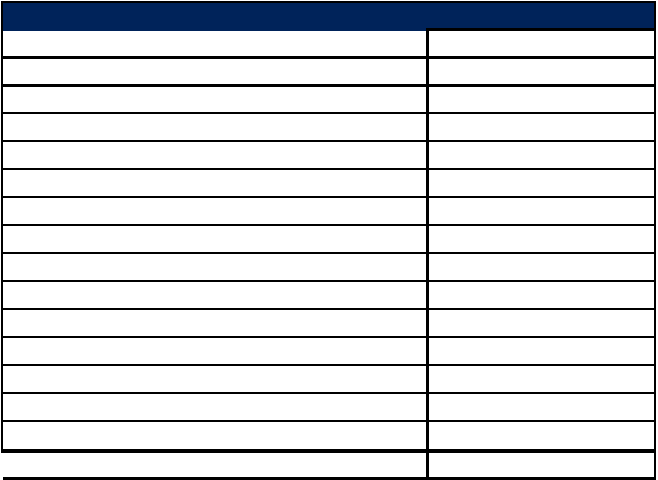

Fixed monthly expenses Payment

Mortgage

Second mortgage

Gas and electric

Heating oil

Water and sewer

Telephone

Car payment one

Car payment two

Auto insurance

Life insurance

Medical insurance

Alimony/child support

Alarm system

Property taxes/insurance

Other/Minimum credit card payment

Subtotal, FIXED expenses

B. Your monthly income


Before taxes | After taxes

Spouse or partner’s income:

Before taxes | After taxes

Other household income:


Before taxes | After taxes

Variable monthly expenses Payment

Groceries

Eating out

Gas

Bus/taxi/parking

Car repair

Toiletries/hair care

Medical/prescriptions

Day care

Cable TV

Clothing/laundry

Lottery

Church/charity

Entertainment

Cell phone

Other

Subtotal, VARIABLE expenses

C. Credit card and other debts:

 | Creditor name | Min. payment Balance


Add Fixed and Variable expenses to get
TOTAL MONTHLY EXPENSES

D. Surplus/deficit:


Total net monthly household income

Subtract total monthly expenses

= Monthly surplus or deficit

