Direct Deposit Authorization Form | šHR_3_Benefits_Retirement_Deduction_MiscUœ
University of Massachusetts – Amherst | EmplID
University of Massachusetts – Amherst | HR EmplD __ __ __ __ __ __ __ __
 | our EmplID is 8 digits long. Please write your SSN above only
 | if you have not yet been paid by the University thus do not
 | have an EmplID. Thank you.

Name ________________________________________________________________________

Phone ___________________ Email ________________________________________________

Action Requested (Check |  |  | One) | Start Direct Deposit | Stop Direct Deposit | Change (add/delete a bank, increase/decrease
 |  |  |  |  |  | fixed amount or select new balance account)
* A change replaces the direct deposit authorization currently on file. Fill in every row of bank information to show how your check should be deposited.
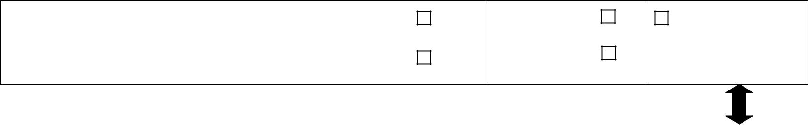

Bank Name | Routing # | Checking
 | __ __ __ __ __ __ __ __ __ | Checking
 | (9 digits) | or
 | Acct# _____________________ | Savings

Full Deposit

or

Fixed Amount

$_____________________

Balance Account

Deposit any balance of net pay to this account

If depositing more than one (1) bank, you must choose one Balance Account.

Bank Name | Routing # | Checking | Full Deposit | Balance Account
 | __ __ __ __ __ __ __ __ __ | Checking | or
 | __ __ __ __ __ __ __ __ __ |  | or | Deposit any balance of net
 | (9 digits) | or | or | Deposit any balance of net
 | (9 digits) | or | Fixed Amount | Deposit any balance of net
 | Acct# _____________________ | Savings | Fixed Amount | pay to this account
 | Acct# _____________________ | Savings | $_____________________
Bank Name | Routing # | Checking | Full Deposit | Balance Account
 | __ __ __ __ __ __ __ __ __ | Checking | or
 | __ __ __ __ __ __ __ __ __ |  | or | Deposit any balance of net
 | (9 digits) | or | or | Deposit any balance of net
 | (9 digits) | or | Fixed Amount | Deposit any balance of net
 | Acct# _____________________ | Savings | Fixed Amount | pay to this account
 | Acct# _____________________ | Savings | $_____________________
Bank Name | Routing # | Checking | Full Deposit | Balance Account
 | __ __ __ __ __ __ __ __ __ | Checking | or
 | __ __ __ __ __ __ __ __ __ |  | or | Deposit any balance of net
 | (9 digits) | or | or | Deposit any balance of net
 | (9 digits) | or | Fixed Amount | Deposit any balance of net
 | Acct# _____________________ | Savings | Fixed Amount | pay to this account
 | Acct# _____________________ | Savings | $_____________________

I authorized the University of Massachusetts to deposit my net pay via direct deposit to my account(s) as indicated above. If funds to which I am not entitled are deposited to my account(s), I authorize the University to direct the financial institution(s) to return said funds.

I understand that it is my responsibility to verify that payments have been credited to my account(s) and that the University assumes no liability for overdrafts for any reason. I understand that in the event my financial institution(s) is/are not able to deposit any electronic transfer into my account due to any action I take, the University cannot issue to funds to me until the funds are returned to the University by my financial institution(s).

I understand this authorization will override any previous authorization and will remain in effect until a( revoked by my written request; or b) immediately following my termination from employment with the University; or c) 120 days after my last paycheck was issued.

I understand I must immediately notify the Payroll Office before I close any/all account(s) listed above while this authorization is in effect.

Employee Signature ________________________________________ Today’s Date __________________________


Attach a voided check and/or deposit slip for each new account entered above.

Bring or send the completed Authorization form with attached check(s)/deposit slip(s) to:

Human Resources, 3rd floor, Whitmore Administration Building.

Please allow up to five (5) weeks (2 pay cycles) for this authorization to take effect.

Questions? Call the Payroll Office, (413) 545-3761 or 545-0391

